Lesson 3: Creating Advanced Visualizations in Tableau
a) Create stacked and grouped bar charts for comparison
b) Build tree maps and pie charts for part-to-whole analysis
c) Design scatter plots to identify relationships
d) Create dual-axis and combination charts
e) Develop histograms for distribution analysis
f) Build box-and-whisker plots
g) Use Gantt charts and advanced date visualizations

Step A: Creating Stacked and Grouped Bar Charts for Comparison
- Connecting to the Dataset
- Launch Tableau. Under the Connect panel, click on Text File, select your startup_funding.csv, and click Open.
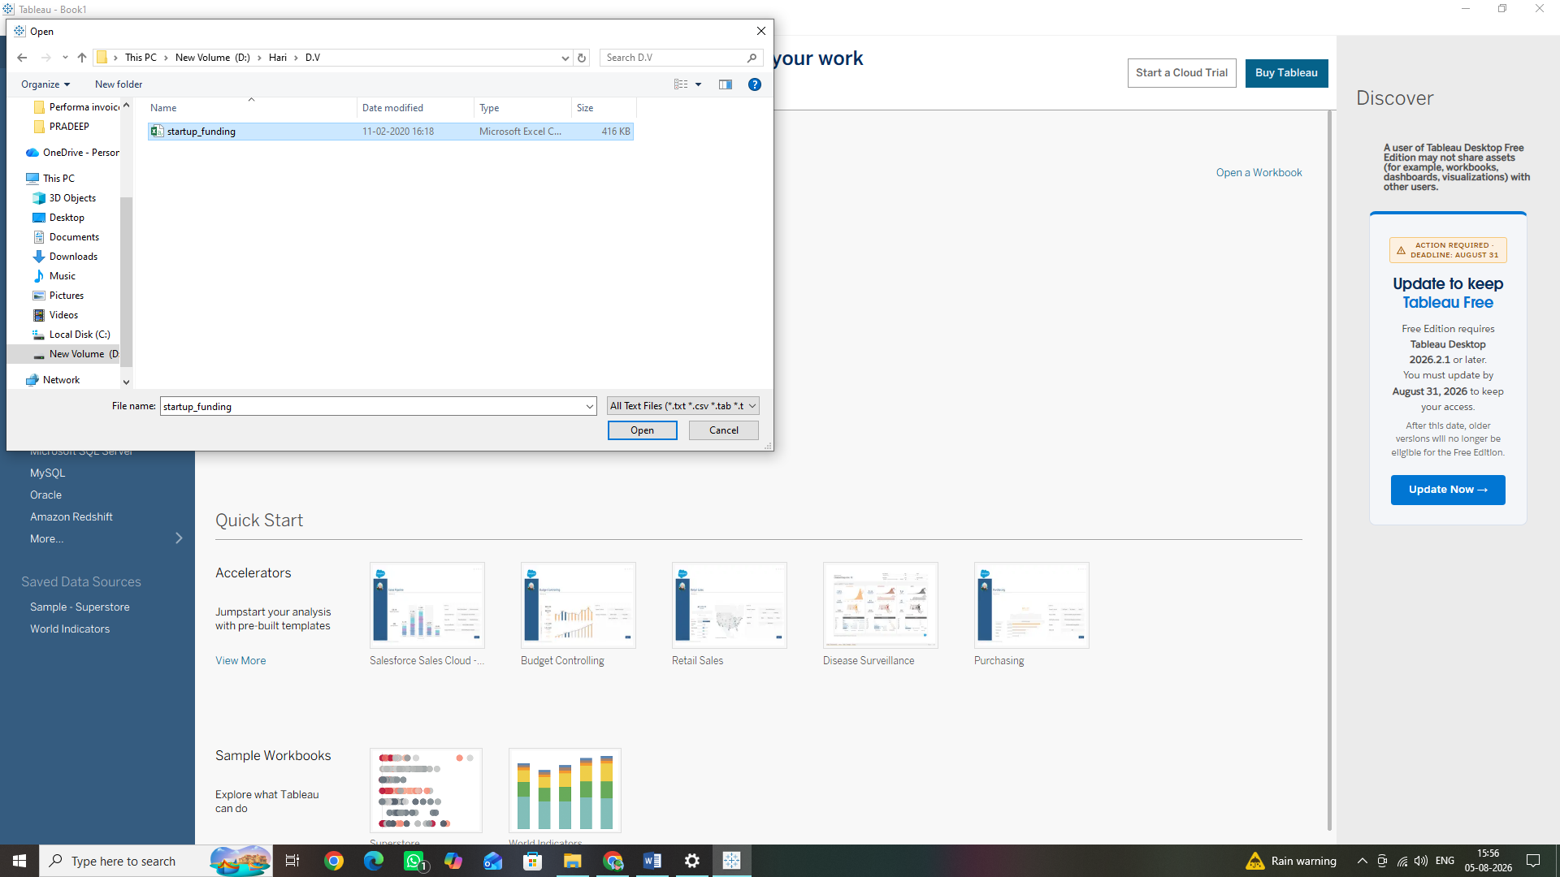

2.Click on Sheet 1 at the bottom-left corner to enter your workspace
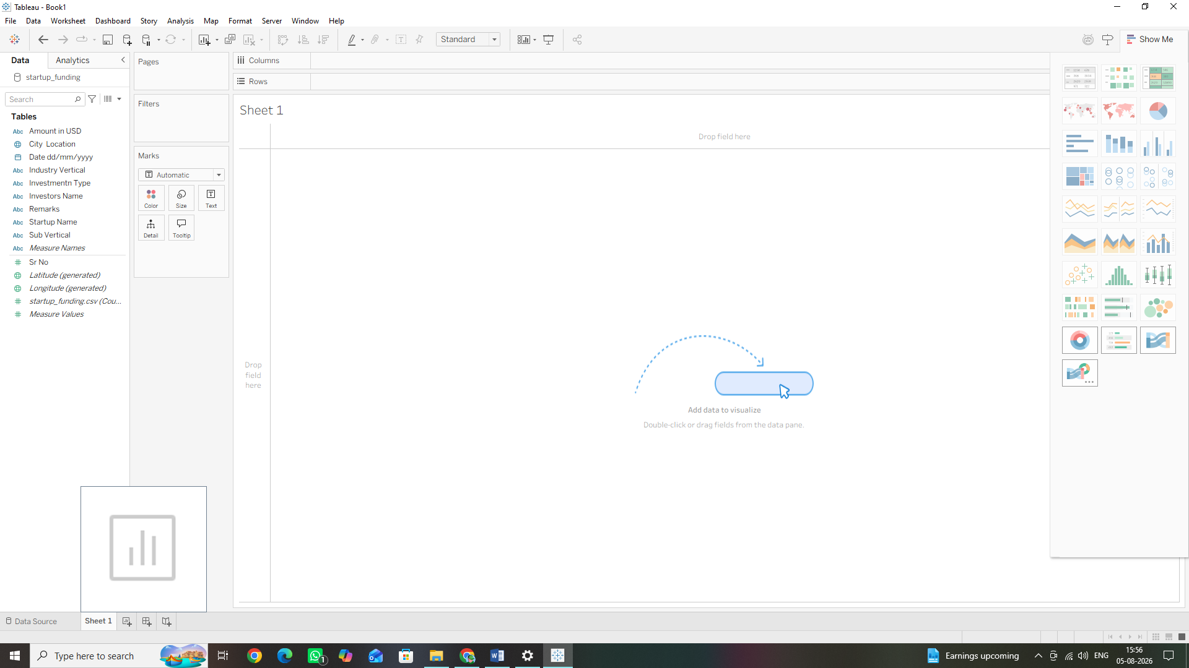

3. Fix the Data Type: In the Data pane on the left, locate Amount in USD. Click the small Abc text icon next to it and select Number (Whole) from the dropdown menu to convert it into numeric data.
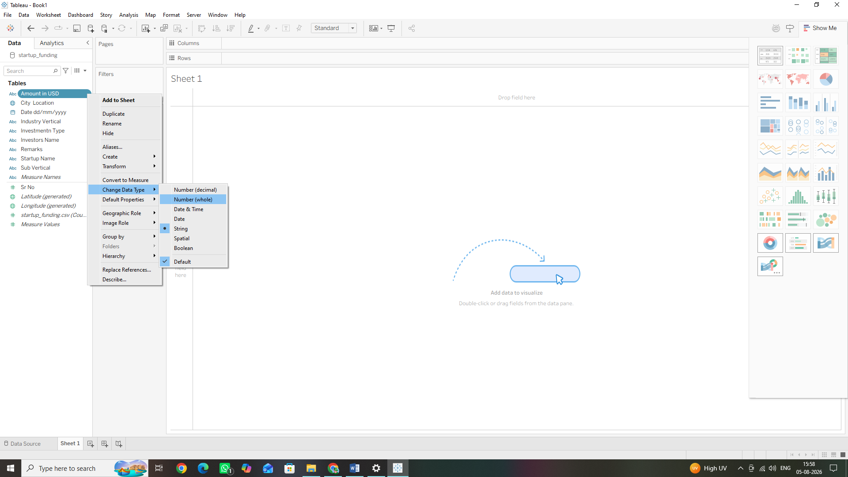

4. Convert to Measure: Right-click Amount in USD in the Data pane and select Convert to Measure. It will turn green and move to the bottom half of the pane.
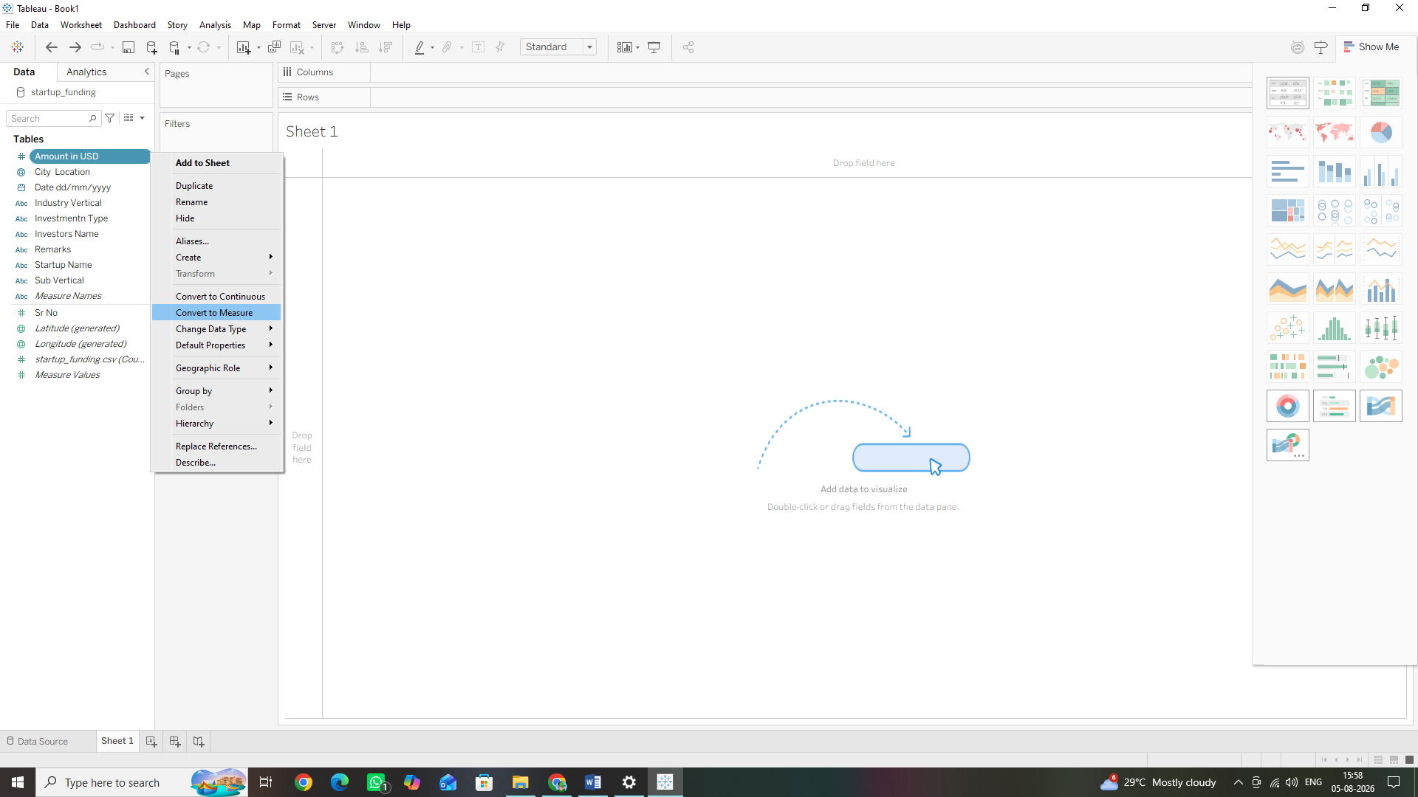
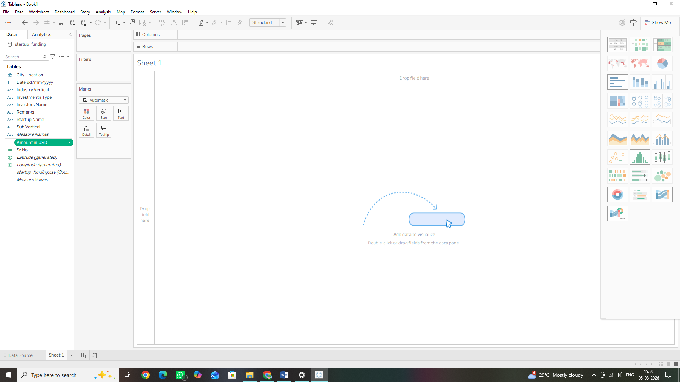

2. Building a Stacked Bar Chart
- From the Data Pane on the left, click and drag the Investment Type dimension onto the Columns shelf.
- Drag the Amount in USD measure onto the Rows shelf.
- Take the City Location dimension from the Data Pane and drop it directly onto the Colour tile in the Marks card.
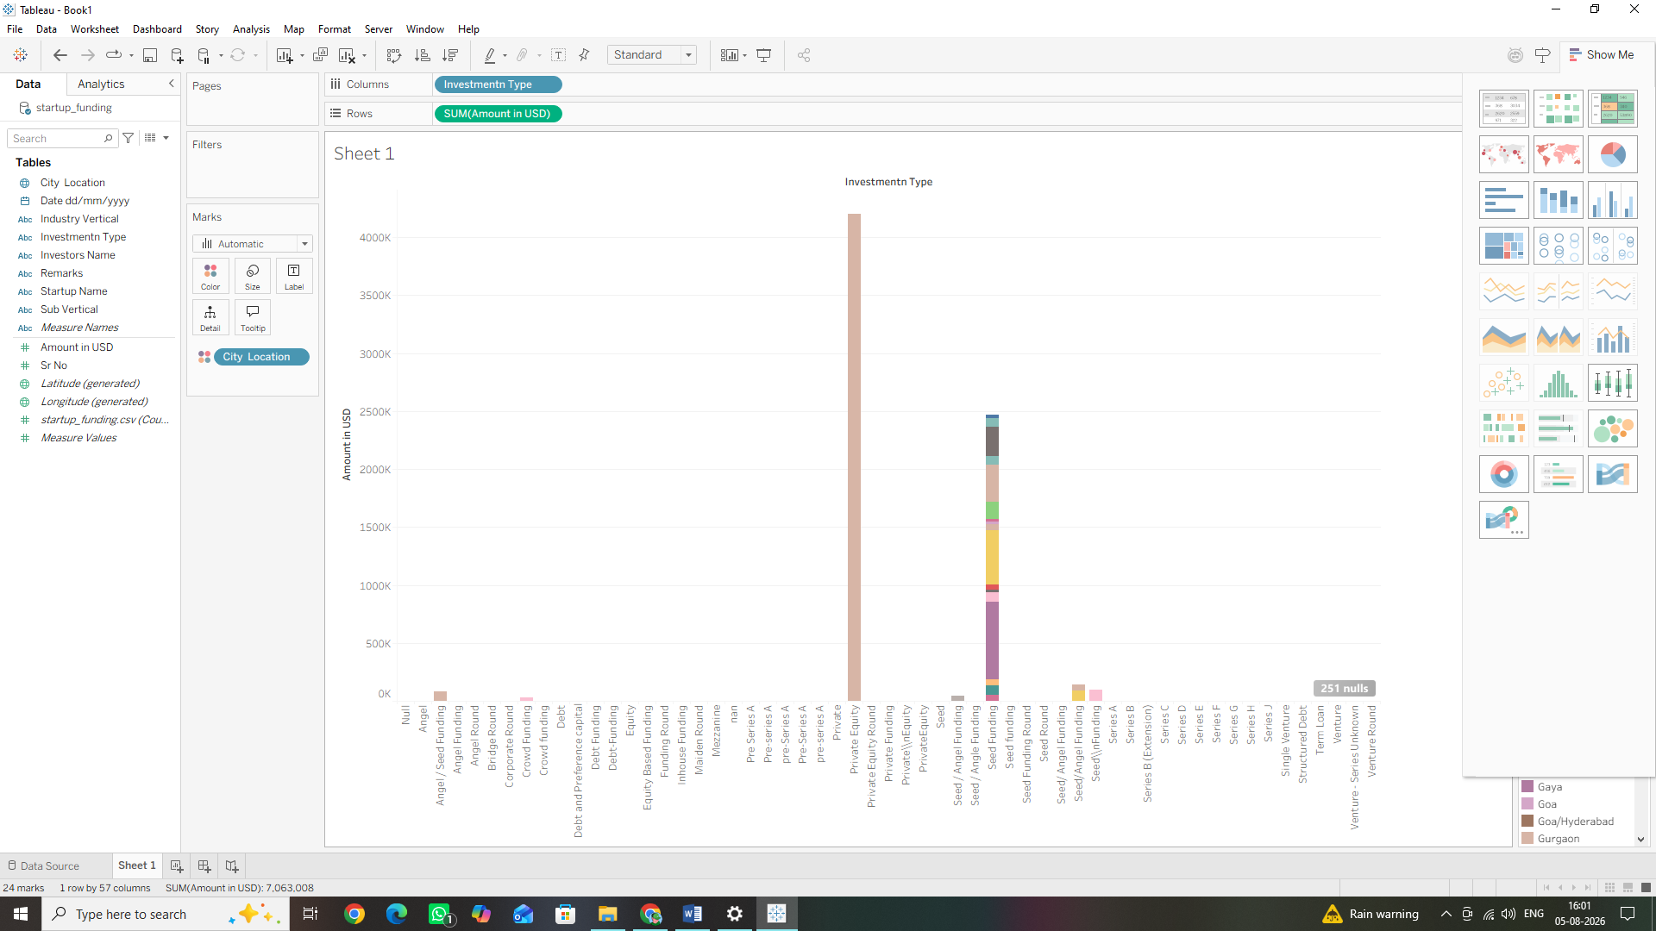
3. Converting to a Grouped Bar Chart (Side-by-Side)
- Leave Amount in USD on the Rows shelf.
- Take the City Location pill out of the Color tile on the Marks card and drag it up to the
Columns shelf, placing it right next to (to the left of) the Investment Type pill.
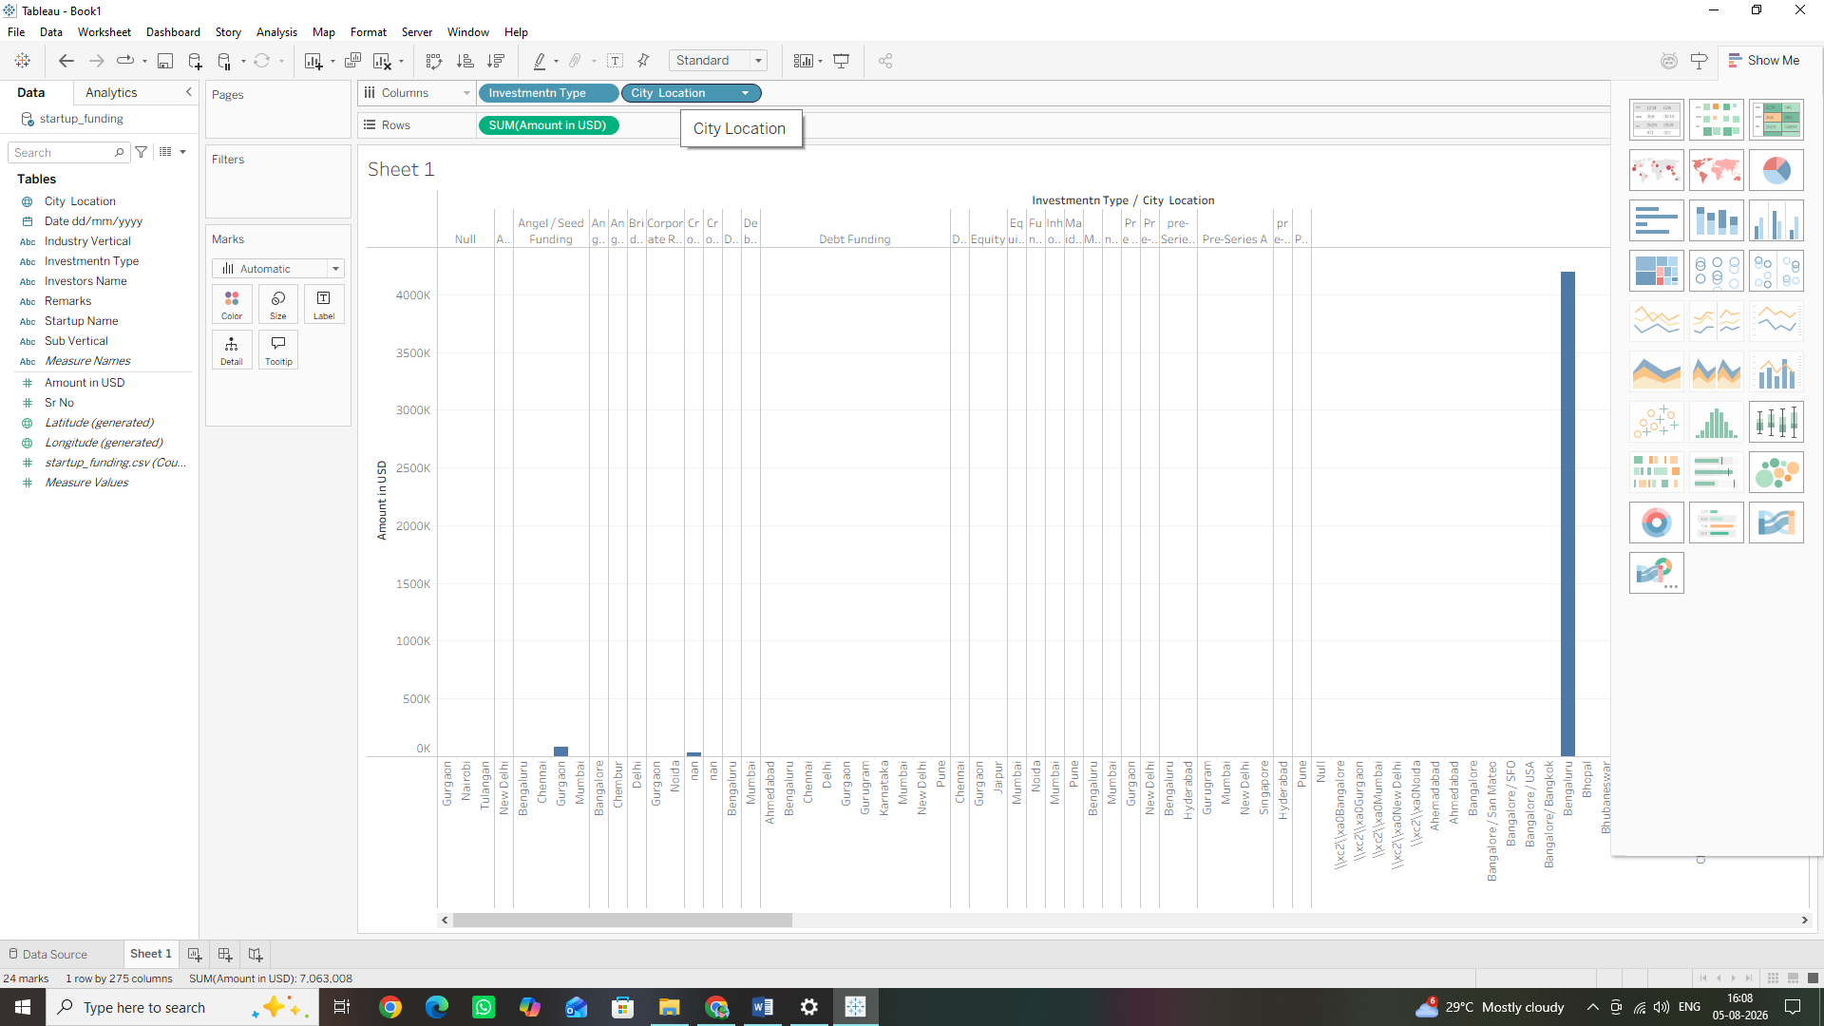

Step B: Building Tree maps and Pie Charts for Part-to-Whole Analysis
  - Building a Tree map
      - Click the New Worksheet icon at the bottom of the screen to open a clean workspace (Sheet 2).
      - From the Data Pane, drag the Industry Vertical dimension and drop it onto the Columns shelf.
      - Drag the Amount in USD measure and drop it onto the Rows shelf. (Tableau will default to generating a standard vertical bar chart).
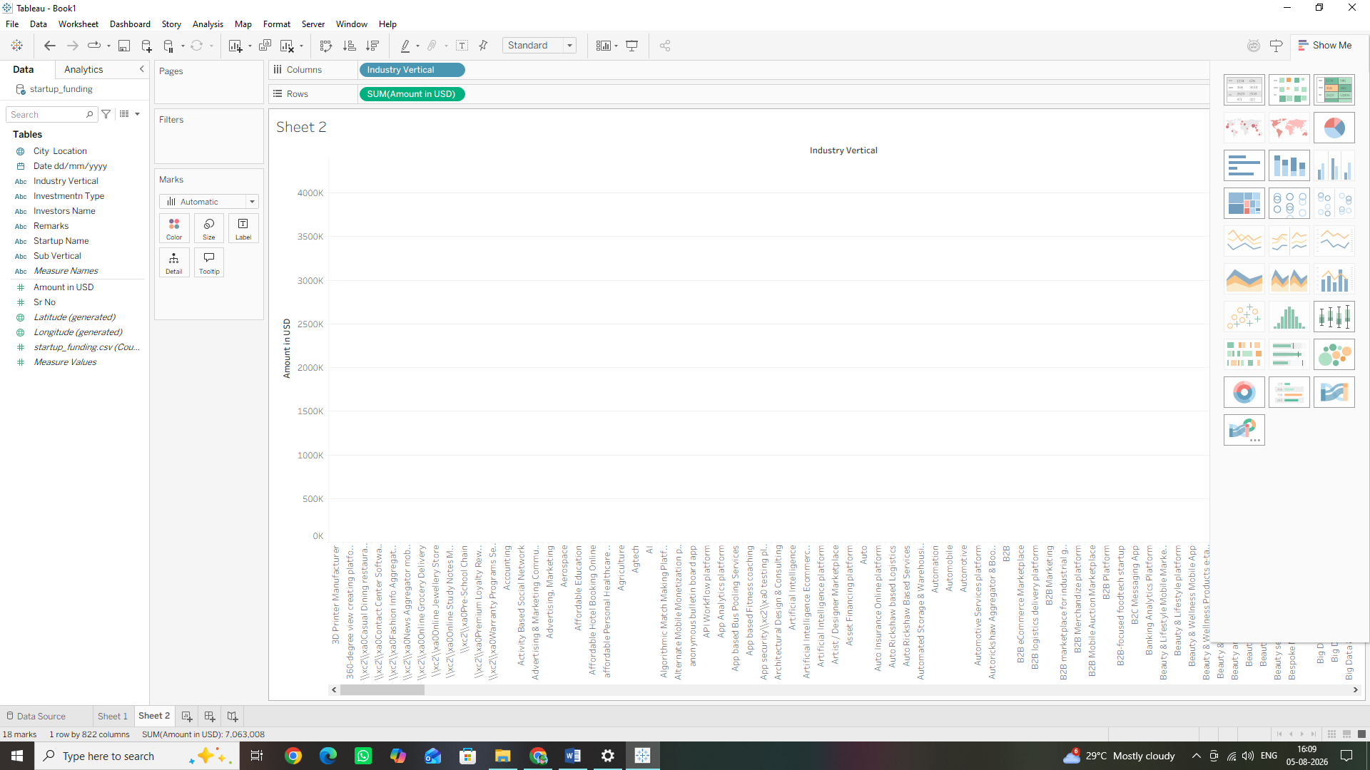
4. Now, look at the very top-right corner of the window and click the Show Me button to expand the chart library panel.
5. From the options, click on the Tree map icon (it looks like a grid of nested colourful rectangles).
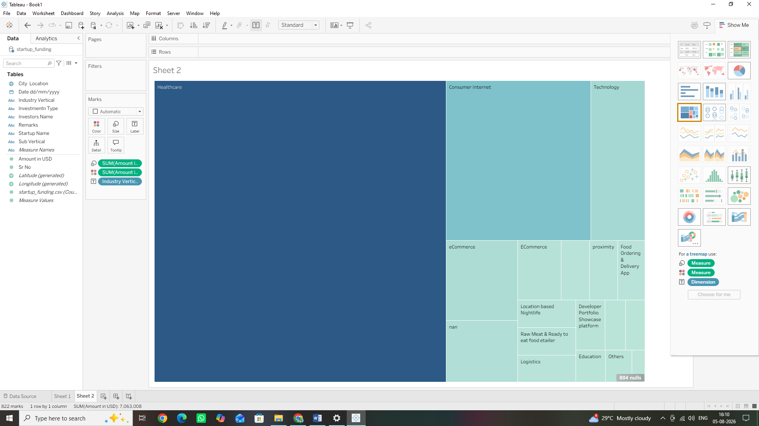

2. Building a Pie Chart
1. Click the New Worksheet icon to open another blank layout (Sheet 3).
2. Go back to the Show Me panel in the top-right corner and select the Pie Chart icon.
3. Notice that your Marks card changes to show an angle option. From the Data Pane, drag Investment Type and drop it onto the Color tile in the Marks card.
4. Drag Amount in USD from the Data Pane and drop it directly onto the Angle tile in the Marks card.
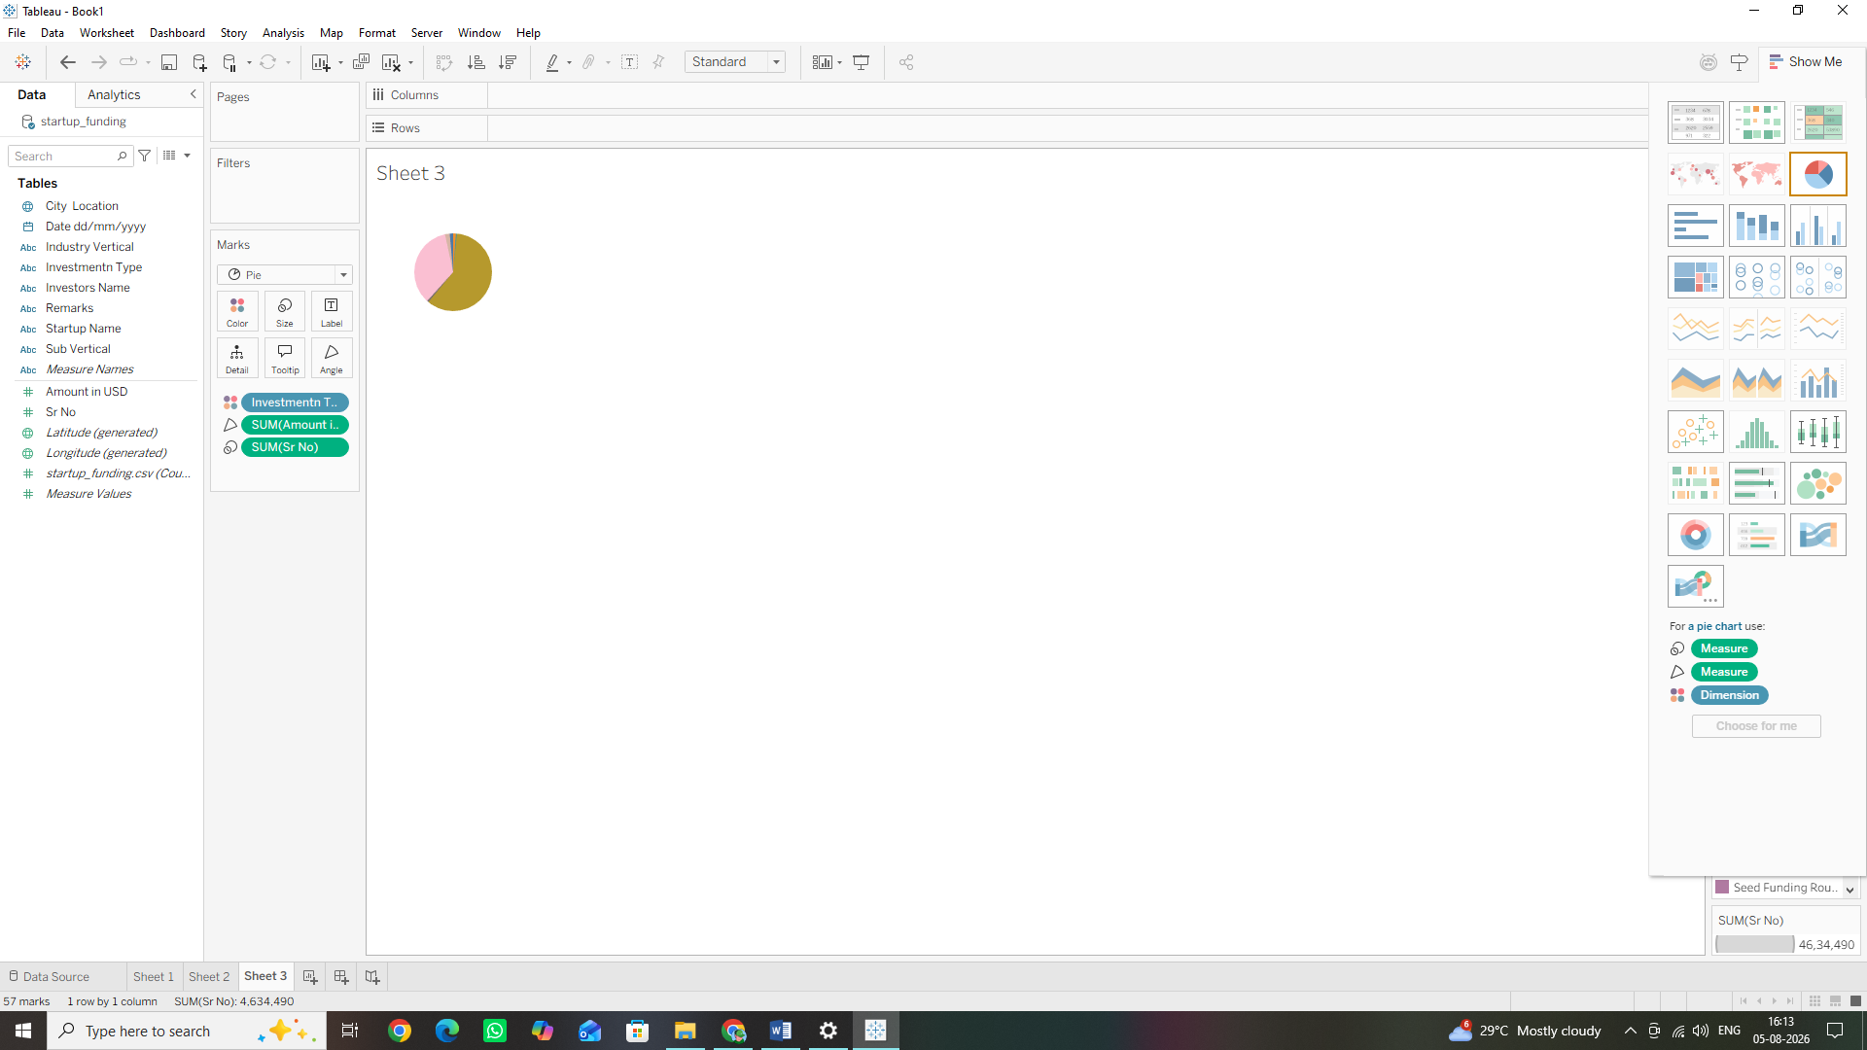

5. Enlarge the view: To make the pie chart legible, look at the top toolbar menu, find the fit dropdown menu (which says Standard by default), and switch it to Entire View.
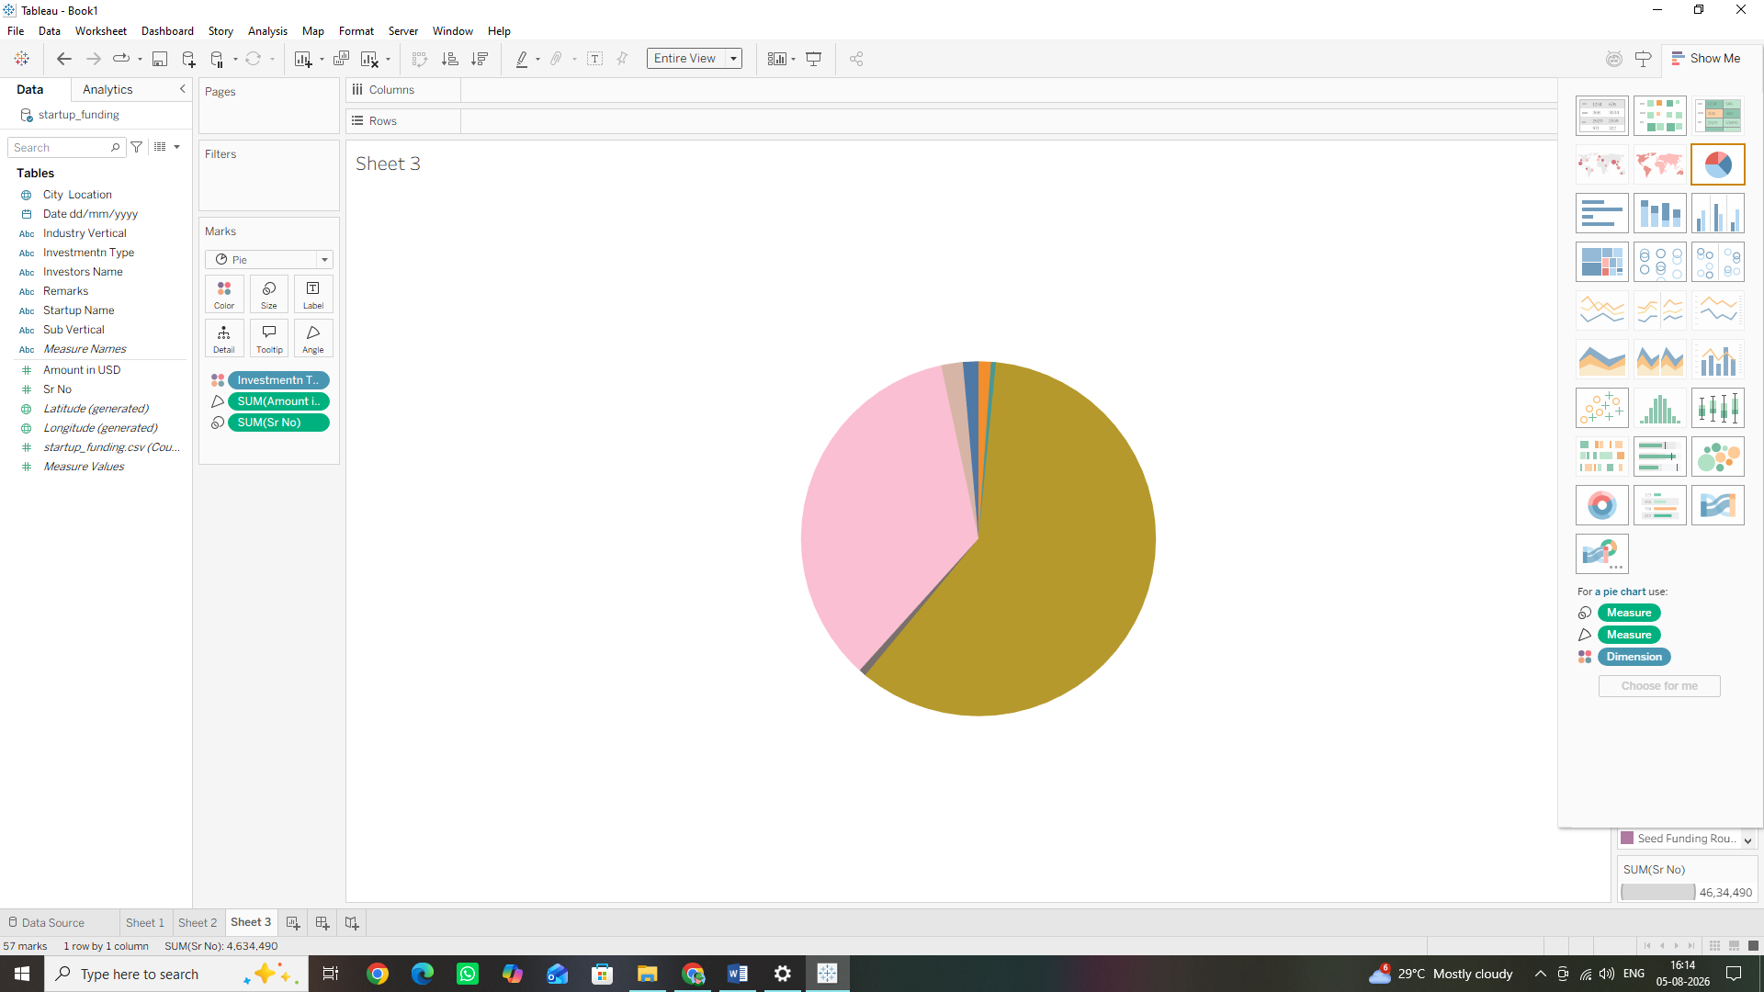

Step C: Designing Scatter Plots to Identify Relationships
1. Cleaning the Data for Scatter Plots
A scatter plot maps relationships between two different numerical measures. However, in this dataset, we only have one explicit primary numeric field: Amount in USD.
To create a meaningful scatter plot, we will instruct Tableau to generate a second numerical measure dynamically by counting the number of times a startup name appears (representing the total number of funding rounds a startup went through).
2. Building the Scatter Plot
1. Click the New Worksheet icon at the bottom of your window to open a fresh canvas (Sheet4).
2. Look down to the bottom of your Data Pane list under the green measures section. Locate the automatic system measure field called startup_funding.csv (Count) (in older versions of Tableau, this is called Number of Records).
3. Drag that Count or Number of Records measure and drop it onto the Columns shelf.
4. Drag your Amount in USD measure and drop it onto the Rows shelf.
o Look closely: Right now, you will see a single, isolated data dot in the center of your
chart canvas. This is because Tableau automatically sums up the values for the entire
dataset into a single aggregated point.
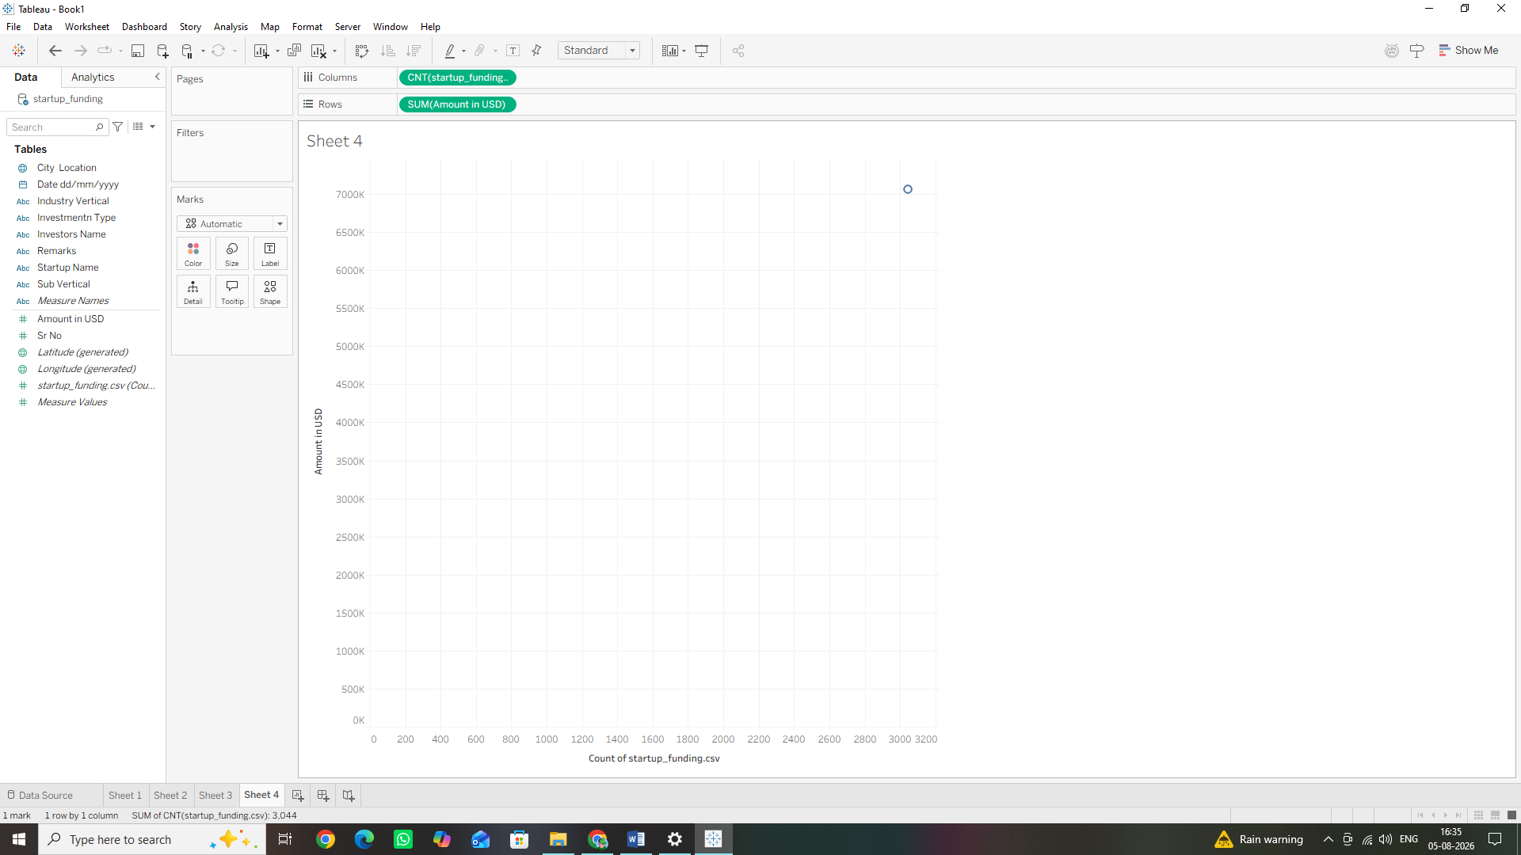
5. To break this single point down into individual startups, find the Startup Name dimension in the Data Pane.
6. Drag Startup Name and drop it directly onto the Detail tile within the Marks card.
7. Adding Context with Color: Take the City Location dimension from your Data Pane and drop it onto the Color tile in the Marks card.
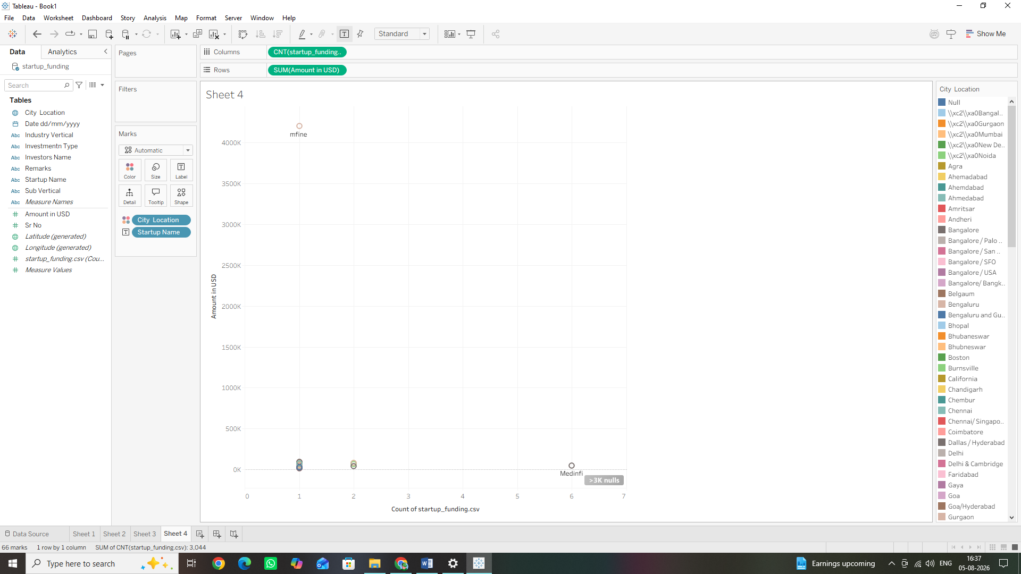

Step D: Creating Dual-Axis and Combination Charts
1. Preparing the Fields
To build a dual-axis combination chart, we need a time element on our horizontal axis ($X$-axis) and two different metrics tracking along the vertical axis ($Y$-axis). We will use the Date dd/mm/yyyy column for time. Before we begin, let's make sure Tableau treats this text field as a proper date:
1. Look at your left-hand Data Pane.
2. Find the field Date dd/mm/yyyy and click the small text icon (Abc) immediately to the left of its name.
3. Select Date from the dropdown menu to convert it into a structured time dimension.
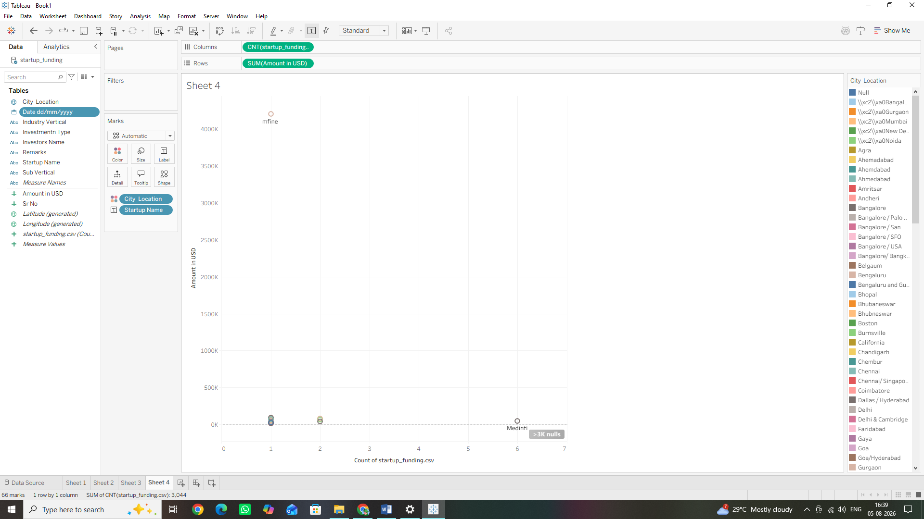

2. Building the Dual-Axis Chart
1. Click the New Worksheet icon at the bottom of the screen to open a fresh canvas (Sheet5).
2. Drag your newly formatted Date dd/mm/yyyy dimension and drop it onto the Columns shelf. (Tableau will automatically group the dates into discrete Years).
3. Drag the Amount in USD measure from the Data Pane and drop it onto the Rows shelf.

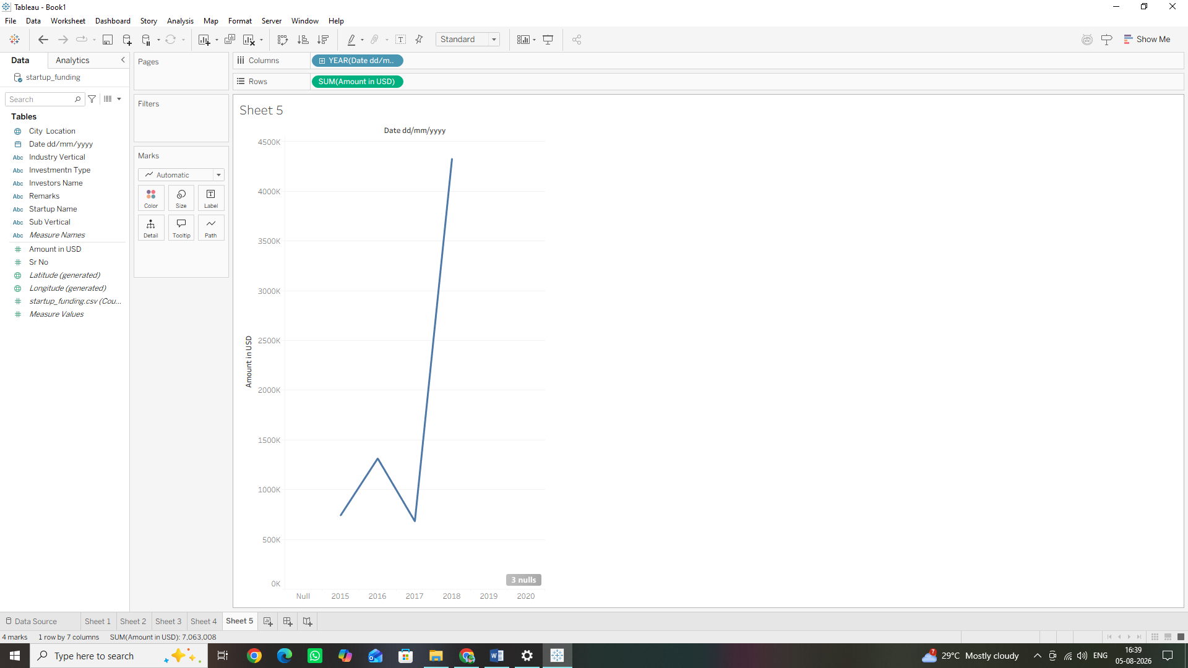
4. Now, take the automatic system measure startup_funding.csv (Count) (or Number of Records) and drag it onto the Rows shelf, placing it directly to the right of the Amount in USD pill.
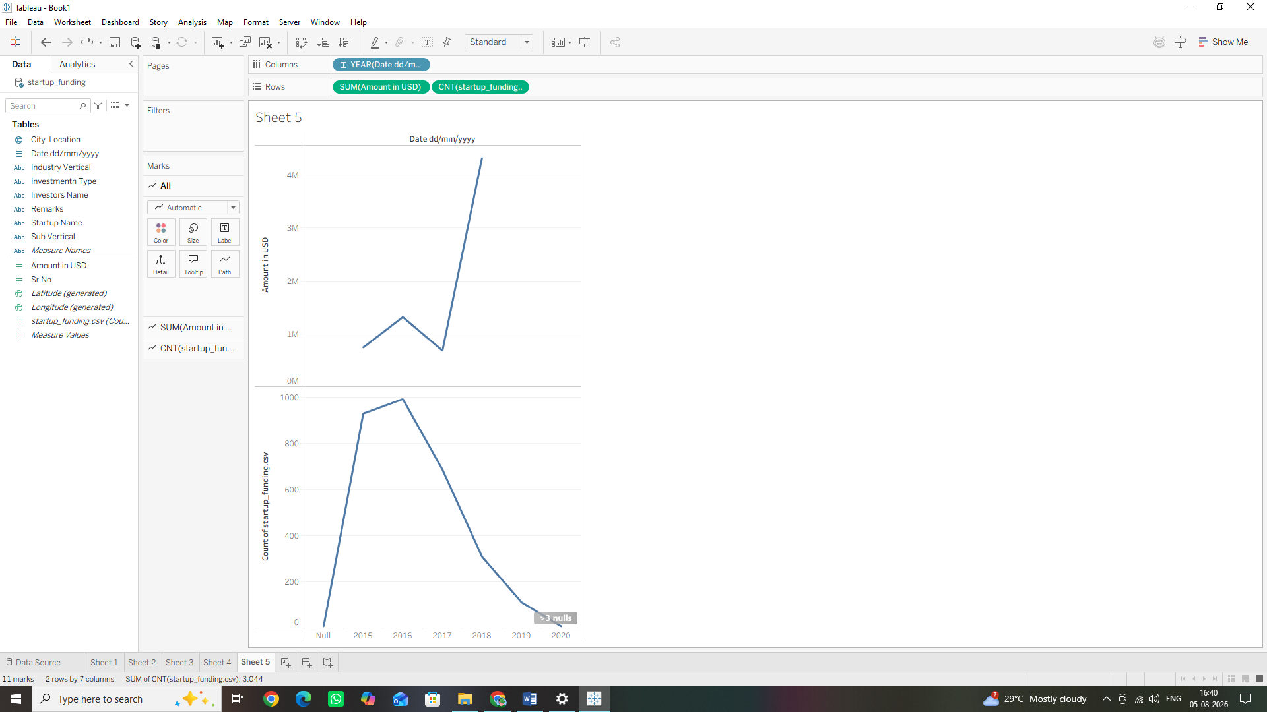

3. Combining and Formatting the Visuals
1. Right-click the second measure pill (startup_funding.csv (Count)) sitting up on the Rows shelf.
2. Select Dual Axis from the context dropdown menu.
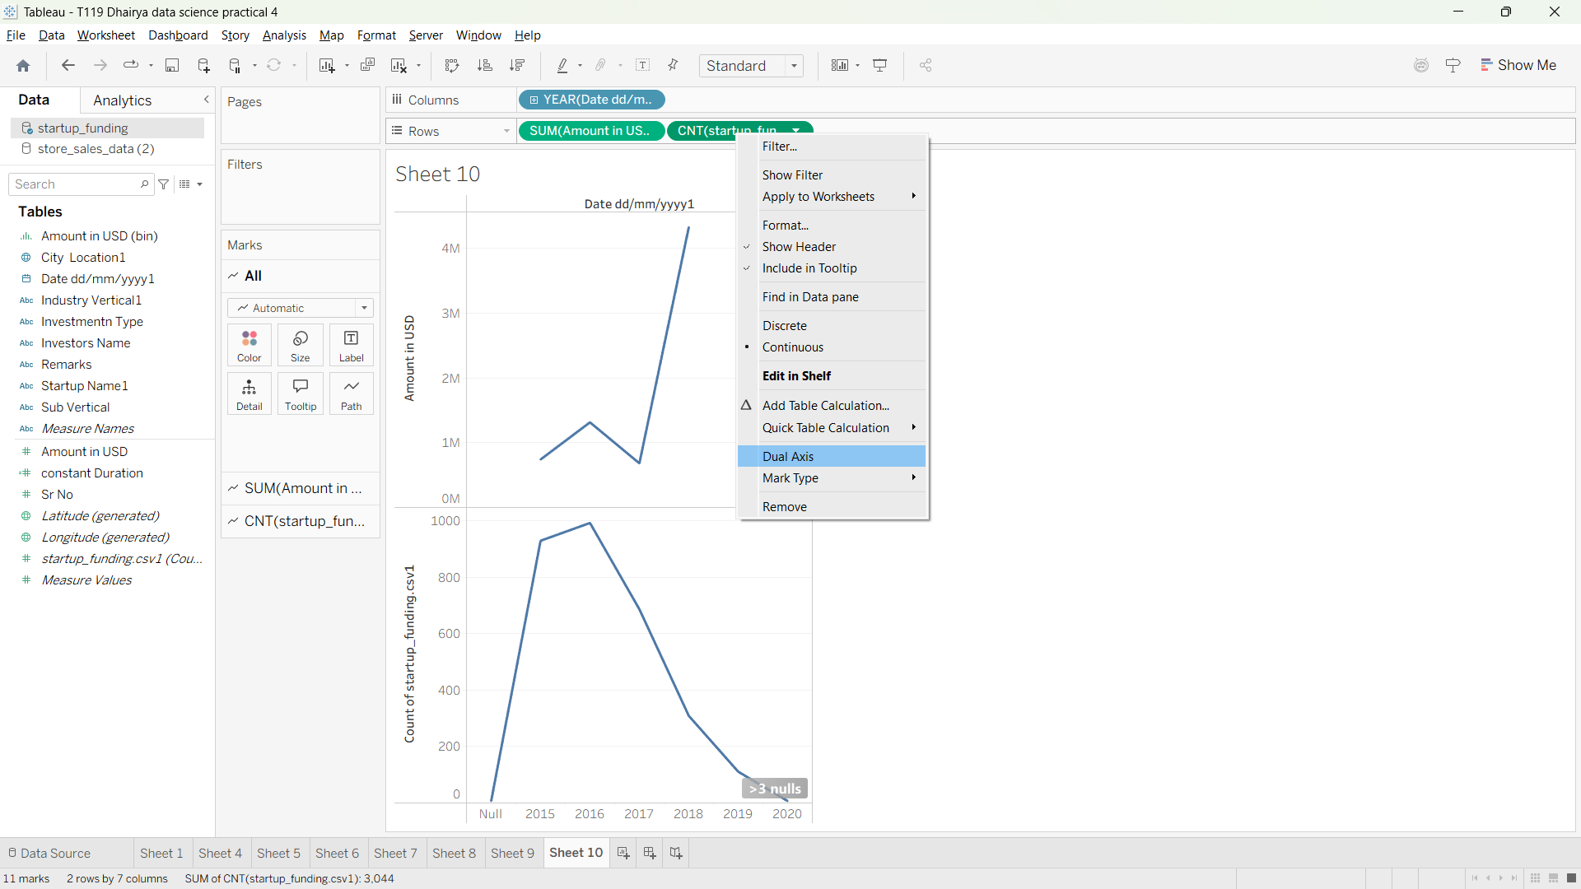
3. Look at your Marks Card area. Notice that it has split into three distinct tabs: All, SUM (Amount in USD), and CNT (startup_funding.csv).
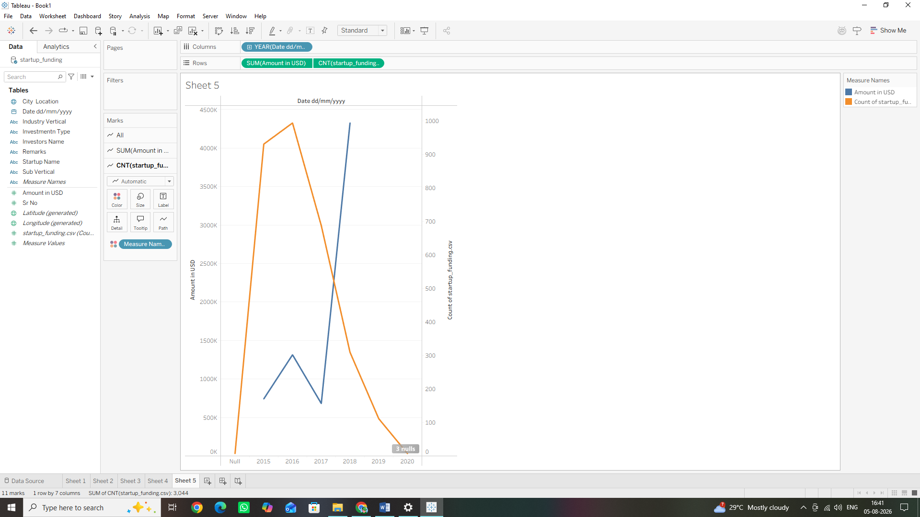

4. Click directly on the SUM (Amount in USD) tab in the Marks card. Change its visual type dropdown selection from Automatic to Bar.
5. Next, click directly on the CNT (startup_funding.csv) tab in the Marks card. Change its visual type dropdown selection from Automatic to Line.
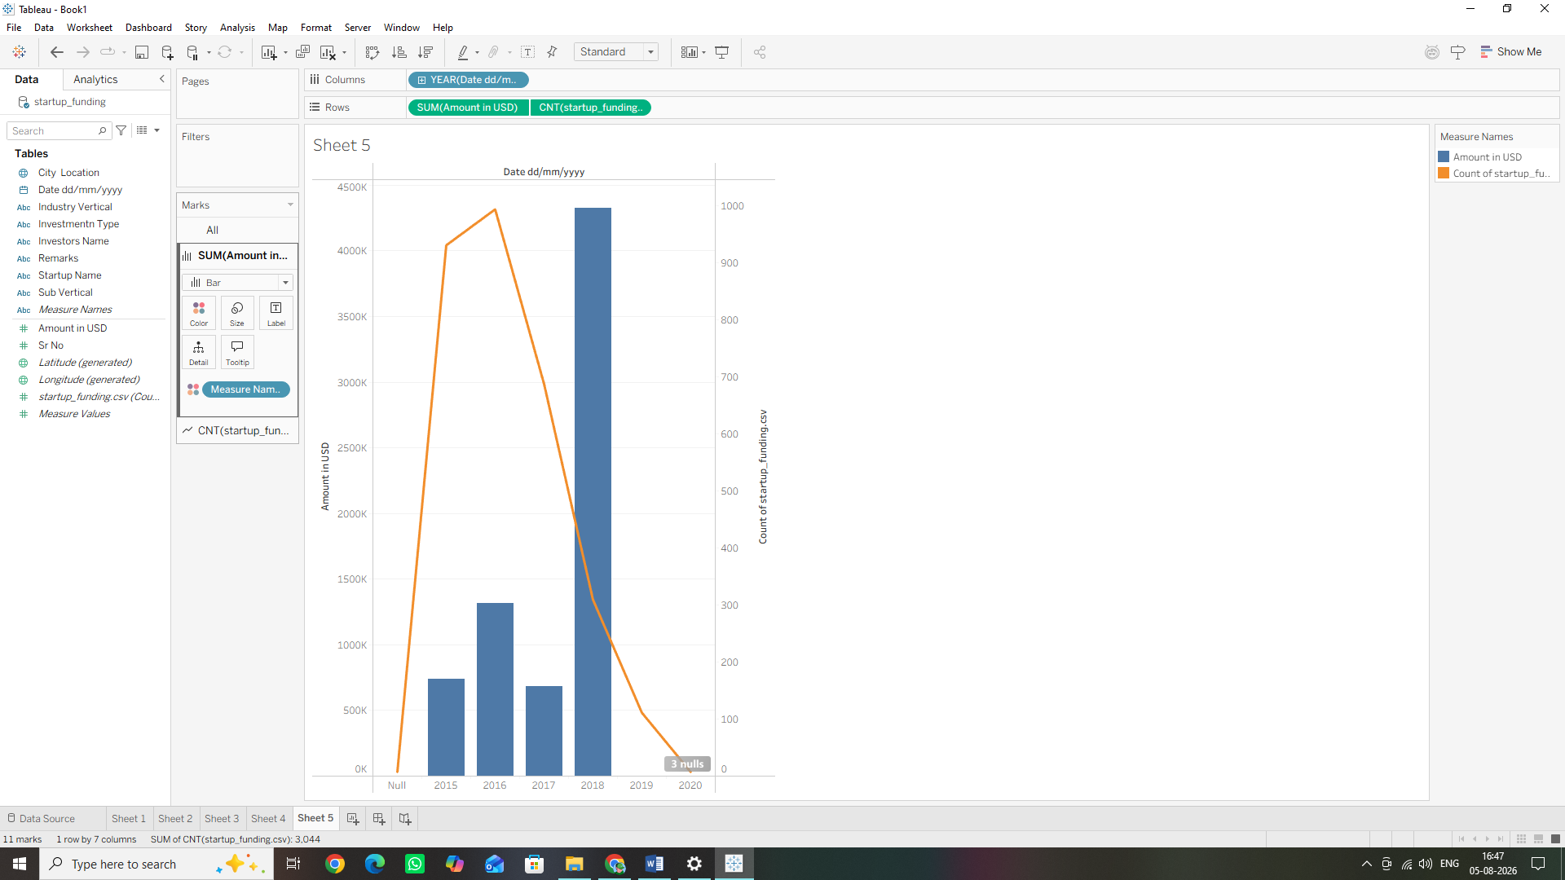

Step E: Developing Histograms for Distribution Analysis
1. Understanding Histograms in Tableau
A histogram splits a single continuous numerical measure into equal, consecutive intervals called Bins (e.g., separating funding amounts into bins of 0–10M, 10M–20M, etc.) and displays the frequency count of records falling within each bucket as a bar chart. Because a histogram relies on a single continuous field to build its own bins, we don't manually drop fields onto both shelves like a normal bar chart.
2. Building the Histogram
1. Click the New Worksheet icon at the bottom of the screen to open a fresh canvas (Sheet6).
2. Go to the Data Pane and click once directly on the Amount in USD measure to highlight it.
3. Move your mouse to the top-right corner of the window and click the Show Me button to expand the chart library panel. (Which is already Expanded)
4. From the options, locate and click the Histogram icon (found in the middle row, displaying vertical green bars).
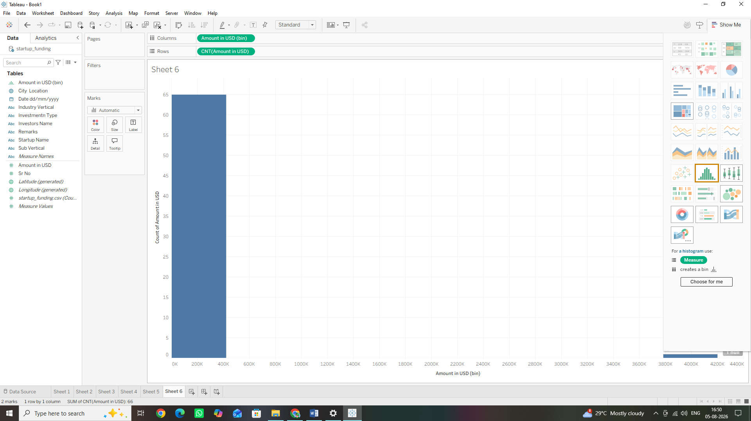
5. Look back at your Data Pane. Notice that Tableau has automatically generated a brand-new field under your dimensions list called Amount in USD (bin) and placed it onto your Columns shelf.
6. Look at the Rows shelf. Tableau has automatically placed the aggregated measure CNT (Amount in USD) there to track record counts.


Step F: Building Box-and-Whisker Plots
1. Cleaning the View for Box Plots
A Box-and-Whisker plot is a statistical chart used to show the distribution of data values based on a five-number summary (Minimum, First Quartile, Median, Third Quartile, and Maximum). Because box plots measure structural distribution across data points, we must tell Tableau tolook at the individual funding records rather than squishing everything into a single consolidated sum bar.
2. Building the Box-and-Whisker Plot
1. Click the New Worksheet icon at the bottom of the screen to open a fresh canvas (Sheet7).
2. Drag the City Location dimension from the Data Pane and drop it onto the Columns shelf.
3. Drag the Amount in USD measure and drop it onto the Rows shelf.
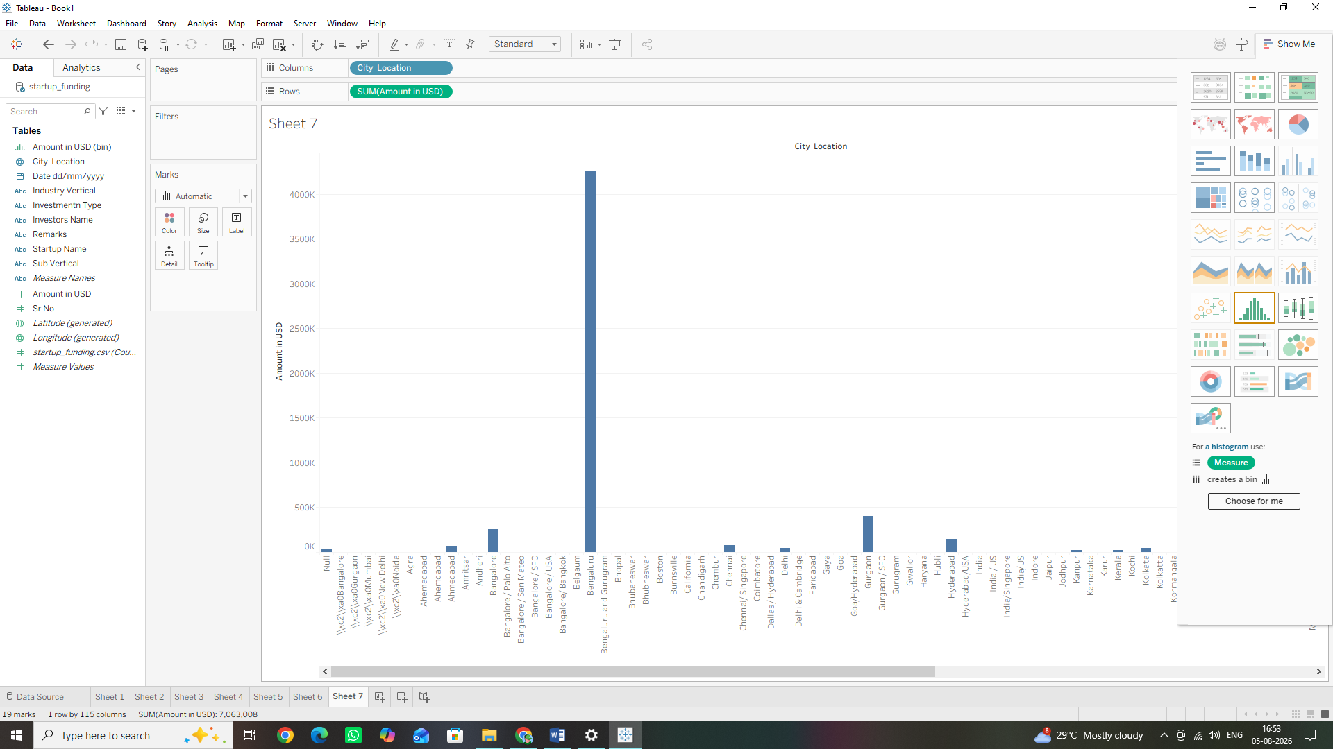

4. Disaggregate the Data Points: Go to the top menu bar click Analysis, and uncheck Aggregate Measures.
After Unchecking
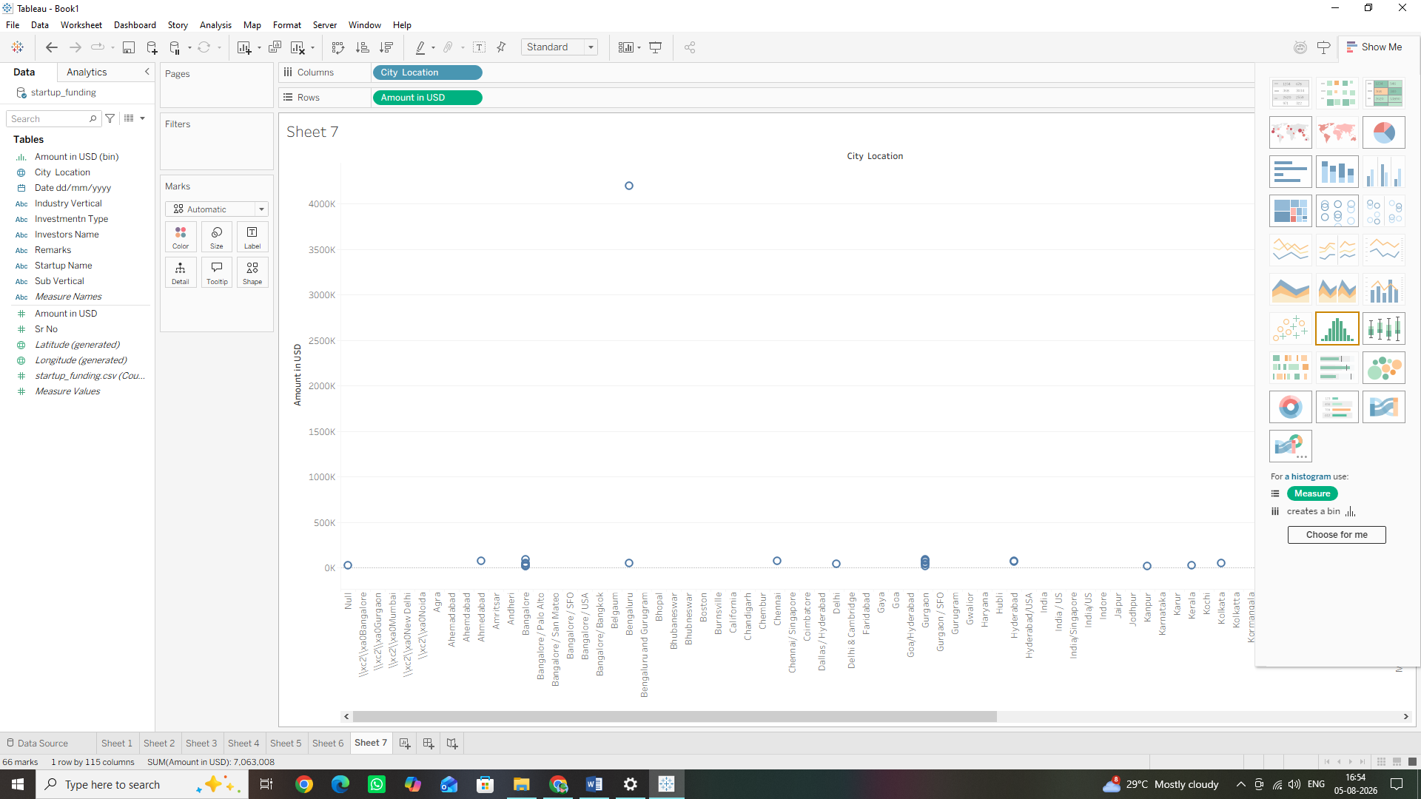
5. Add the Box Plot: Look at the top-right corner of the window, click the Show Me button, and select the Box-and-Whisker Plots icon (found in the middle row, showing a box shape with extended antenna lines).
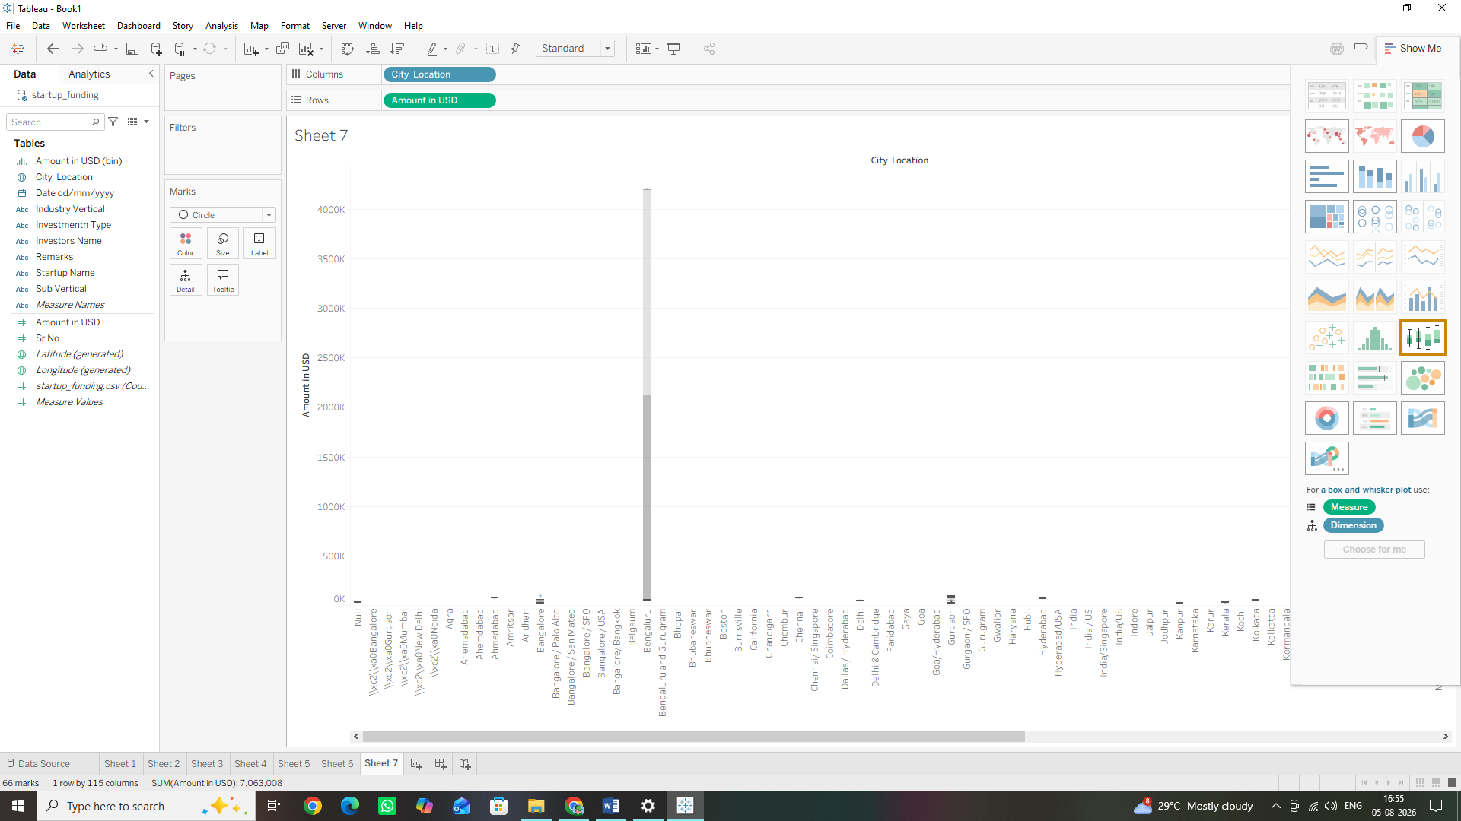

6. Refining the Focus: Since there are many small towns with only one funding record, right-click the City Location pill on your Columns shelf, select Filter, choose only the top tier hubs (e.g., Chennai, Delhi, Gurgoan, Kolkata, Mumbai), and click OK to clean up your distribution view.

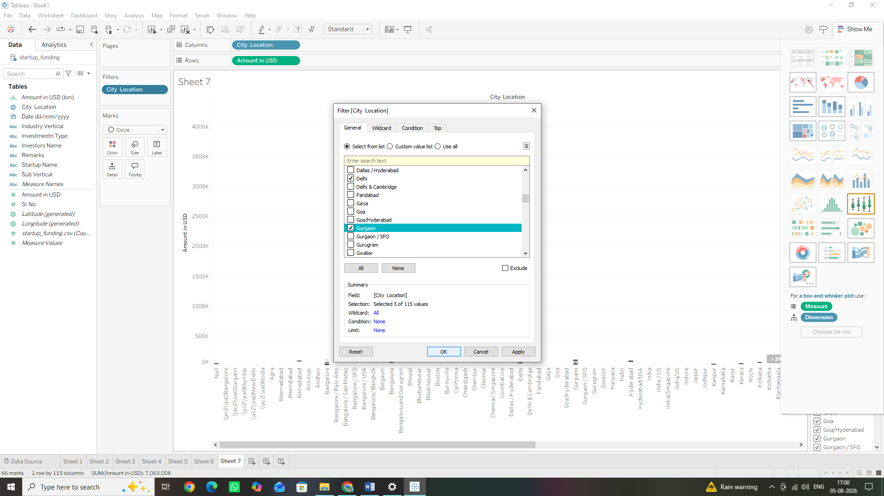
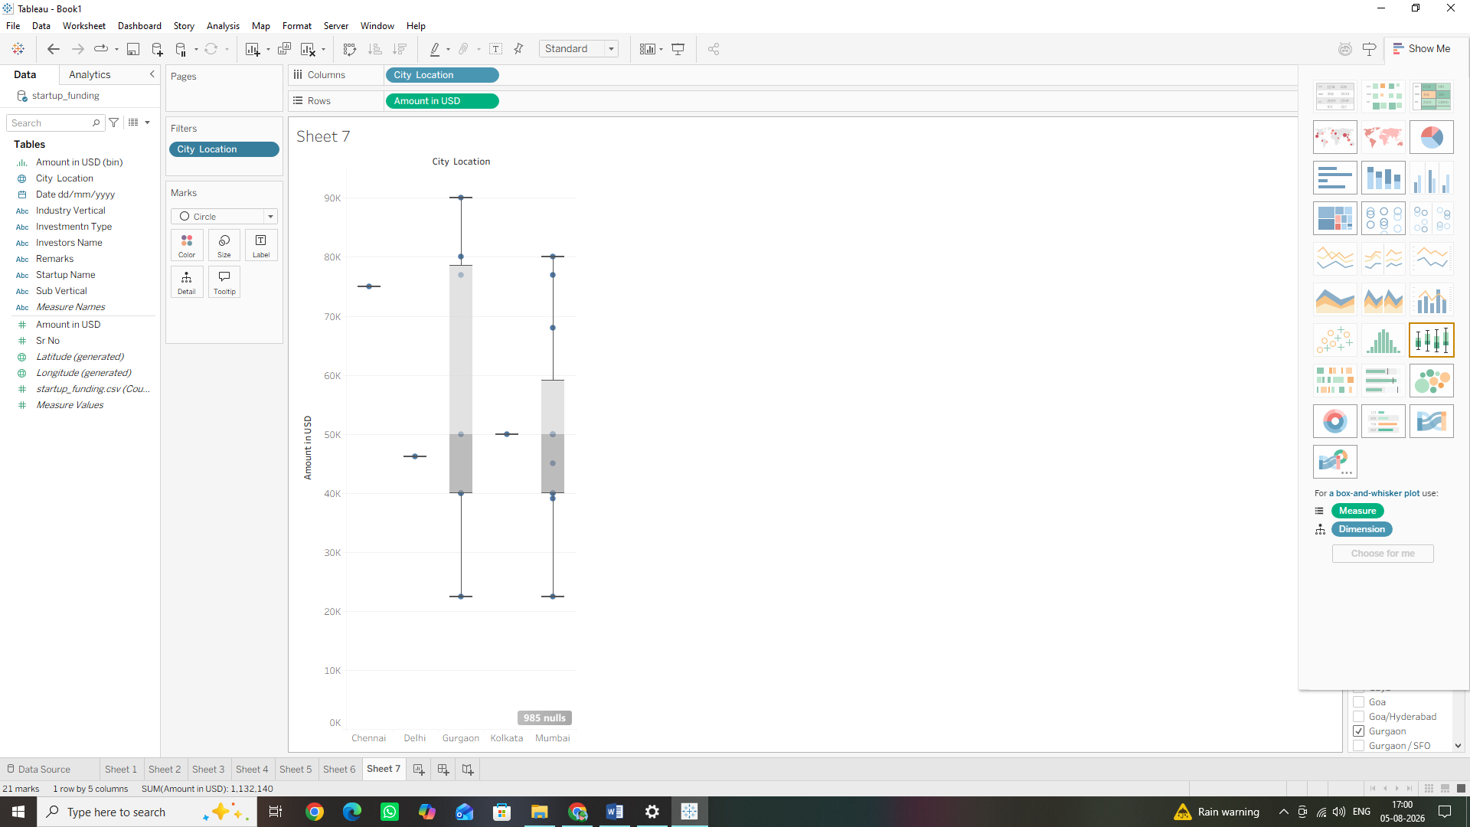

Step G: Using Gantt Charts and Advanced Date Visualizations
1. Understanding Gantt Charts in Tableau
A Gantt Chart is traditionally used to show project schedules and the duration of activities over time. In a standard Gantt chart, the horizontal axis (X-axis) represents a continuous timeline, marks are displayed as horizontal bars, and the length of each bar represents the duration of that specific event. To build a meaningful duration layout using our funding dataset, we will calculate the time spread across funding dates or analyse milestone timelines. However, Tableau also allows us to use the Gantt Bar mark type to build advanced tracking timelines. Let's create an advanced chronological timeline of funding events.
2. Building an Advanced Date Gantt Timeline
1. Click the New Worksheet icon at the bottom of the screen to open a fresh canvas (Sheet8).
2. Look at your left Data Pane. Right-click on your Date dd/mm/yyyy field and select Create> Calculated Field.
3. Name this new calculation Constant Duration. In the calculation box, type simply: 1 (This acts as a uniform placeholder length for our timeline blocks). Click OK.
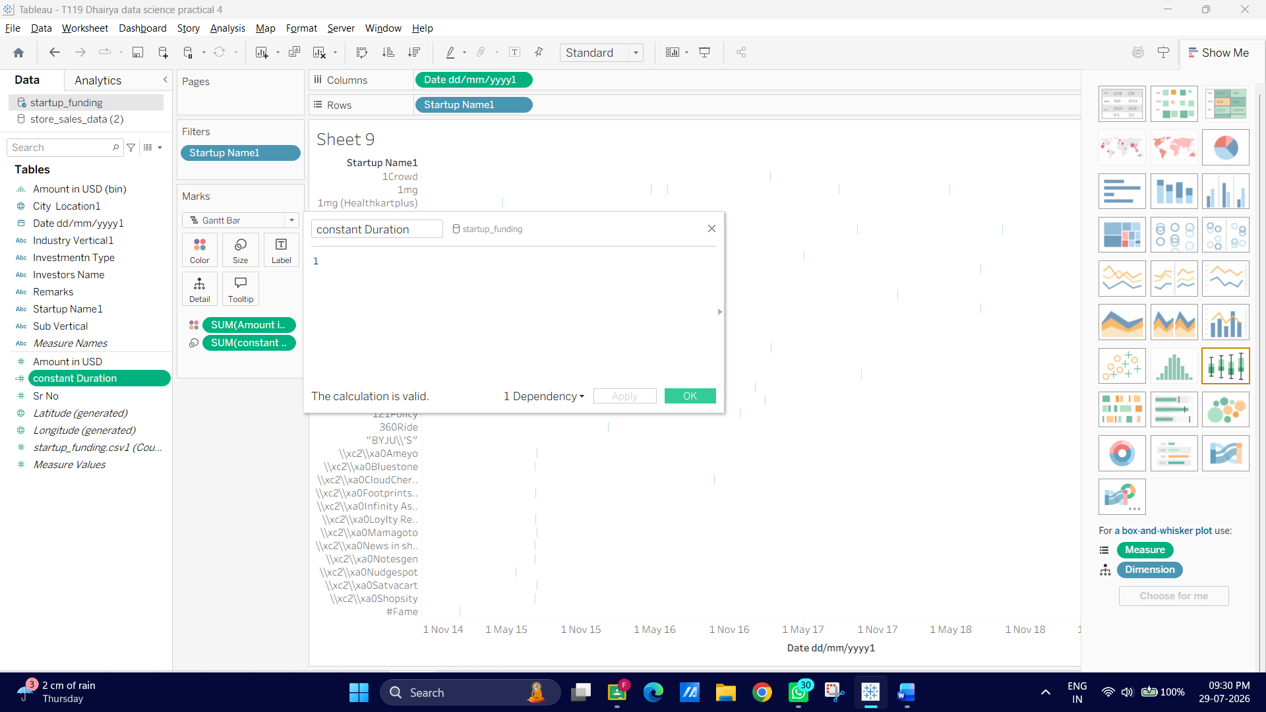

4. Drag your continuous Date dd/mm/yyyy field and drop it onto the Columns shelf.
5. Drag your Startup Name dimension from the Data Pane and drop it onto the Rows shelf.
6. Apply the Filter: Because there are thousands of startups, let's look at a focused subset. Drag Startup Name into your Filters shelf, select a few notable Indian tech giants (e.g., BYJU’S, Flipkart, Ola Cabs, Zomato), and hit OK.
7. Look at your Marks Card dropdown menu (which currently says Automatic). Click it and manually switch the mark style option to Gantt Bar.
8. Take your newly created calculated field Constant Duration from the Data Pane and drag it directly onto the Size tile inside your Marks card.
9. To make the timeline highly informative, drag your quantitative measure Amount in USD from the Data Pane and drop it directly onto the Color tile in the Marks card.
